# Miniproject1 Report

Date: Octorber 13,2021

Ⅰ.Project Outcome

The table below describes the basic outcome, and the advanced outcome that have been successfully accomplished in our miniproject1.

|  |  |  |  |  |  |  |
| --- | --- | --- | --- | --- | --- | --- |
|  | **Basic outcome** | **Advanced outcomes** | | | | |
|  | Low-pass filter | High-pass filter | Band-pass filter |  | GUI | 3-band equalizer |
| Rectangular  Hanning  Hamming  Blackman | **successful** | **successful** | **successful** |  | **successful** | **successful** |

Ⅱ.Individual contribution

|  |  |  |  |  |
| --- | --- | --- | --- | --- |
| Huang Zekai | Lin Jihang | Xu Tianyi | Yang Yiming | Zhu Ziyu |
| 20% | 20% | 20% | 20% | 20% |

Ⅲ.Basic outcome

Low-pass filter

1.The experiment design

The low pass filter is used to filter out the high and medium frequency components of the signal to extract the low frequency components. The window function is used to truncate and smooth the low pass filter.

The design process of window function method for FIR filter is as follows: 

where：s the ideal filter frequency response of approximation；

Design flow chart

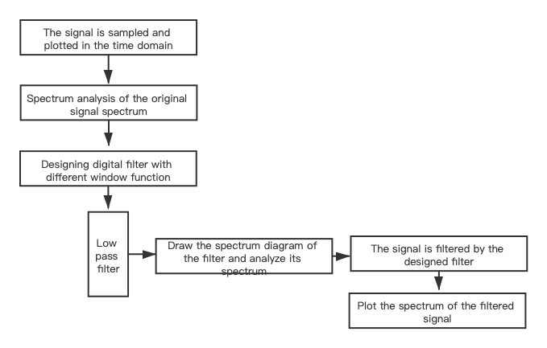

2.The experimental conclusion

After passing the original signal through the designed low pass filter, the waveform in time domain and frequency domain is obtained. Through the analysis and comparison with the original signal, it can be found that the high and middle frequency components of the time domain waveform of the filtered signal are filtered out, and only the low frequency signal is left. By comparing the amplitude spectrum in the frequency domain before and after filtering, it can be found that the amplitude in the low frequency component of the filtered amplitude spectrum is almost the same as the original signal, while the amplitude in the middle frequency and high frequency can be ignored. After comparison, it can be found that the low-pass filter designed by the window function basically meets the design requirements.

When rectangular window, Hanning window, Hamming window and Blackman window are used to design filters with the same N value, the width of the main lobe increases gradually, the transition band becomes wider, but the attenuation.

Ⅳ．Advanced outcomes

1.High-pass filter

1.1 Design principle

As the figure shows,an ideal high-pass filter is equivalent to an all-pass system minus a low-pass filter.So we can do this by subtracting a low pass filter from the unit impulse response of an all-pass system.To obtain the unit impulse response of the high-pass filter we need.The filter is designed by window function,so the subtraction of the unit impulse response can be converted to hd_win3-hd_win.

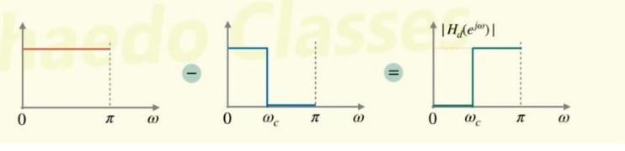

We set the passband cutoff frequency *wp3* and stopband cutoff frequency *w*s3 of a low-pass filter to be equal to a large positive number (much larger than *ws1* of the high-pass filter we want), thus obtaining an all-pass system.

1. Band-pass filter

2.1 Design principle

A bandpass filter can be equal to a low-pass filter minus another low-pass filter.Similar to high-pass filter, we also use hd_win3-hd_win, which is the subtraction method after applying the window function to the unit impulse response.

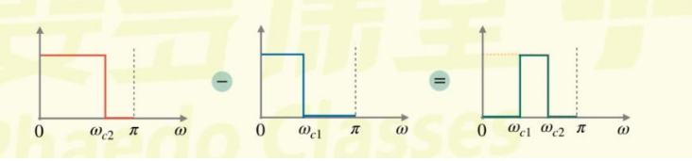

3. GUI

3.1 The design process

1.Create a GUI interface and set the default properties.

2.Create a menu bar.

3.Set up the axis area to make a map.

4.Place controls, such as buttons, text, list boxes, etc.

5.Write the corresponding callback function, paying special attention to the coordination.

4. three-band equalizer

4.1 Design principle

Equalizer realization: use the input function in MATLAB to read each section to enlarge or attenuate multiple.

A1=input('Input A frequency multiplier：')

B1=input('Input B frequency multiplier：')

C1=input('Input C frequency multiplier：')

Then convert decibels according to the formula:

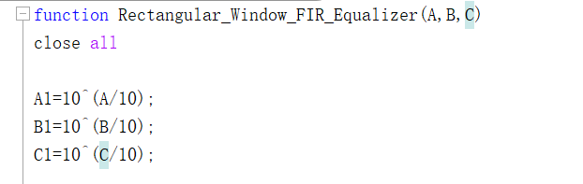

After that,the sampling method of A, B and C bands is realized by designing A low pass filter, A band pass filter and A high pass filter respectively.

Finally,the equalizer output =A1*A unit impulse response +B1*B unit impulse response +C1*C unit impulse response.

Ⅴ.Conclusion

In the MATLAB environment, FIR filters with strict linear phase can be designed conveniently and quickly, which saves a lot of programming time and improves programming efficiency. Moreover, parameter modification is also very convenient, and further optimization design can be carried out. I believe that with the continuous improvement of the version, MATLAB will play a greater role in digital filter technology. At the same time, MATLAB is used to calculate the design parameters of digital filter, such as H(z), H(n), etc., for the hardware implementation of digital filter also provides a simple and accurate way and basis.